**2. Create Linux EC2 instance with required VPC Configurations as above.**

First, create a VPC and EC2 Instance with Amazon Linux AMI and install webserver and host your index file on EC2.

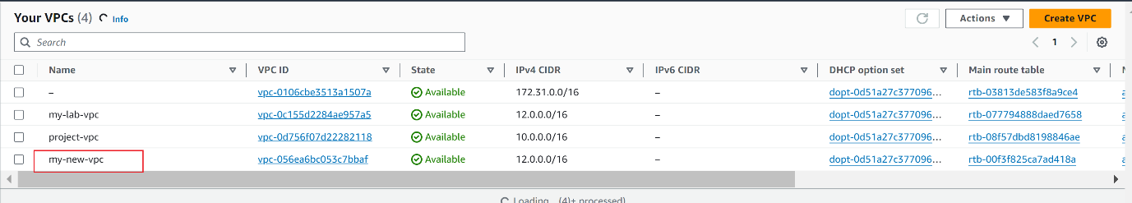

Create internet gateway and attach to the VPC

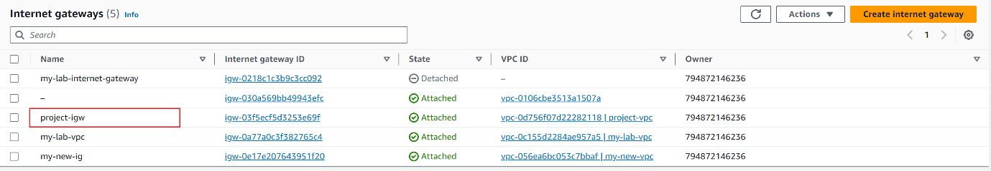

**Create 2 subnets, one public and other private subnets**

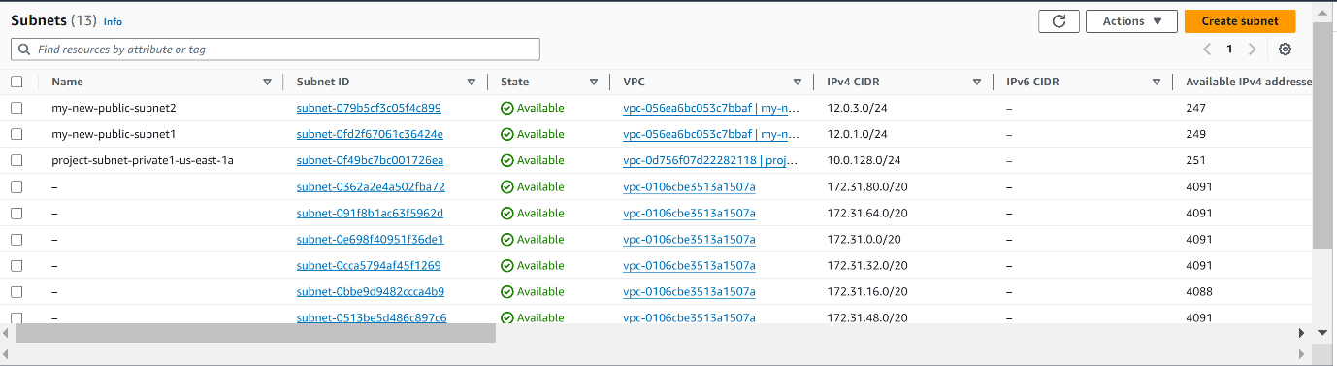

Create a route table and associate to public subnet.

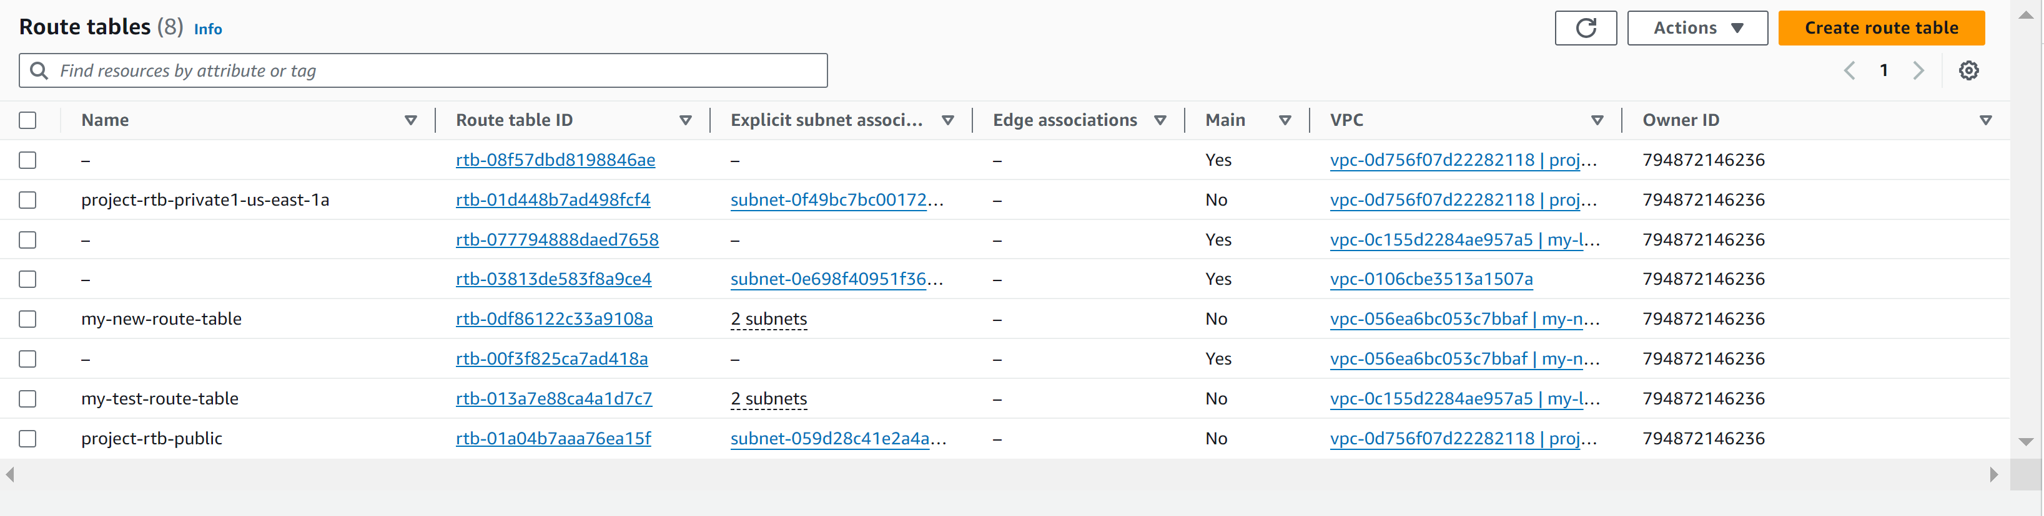

Edit the route with following configurations

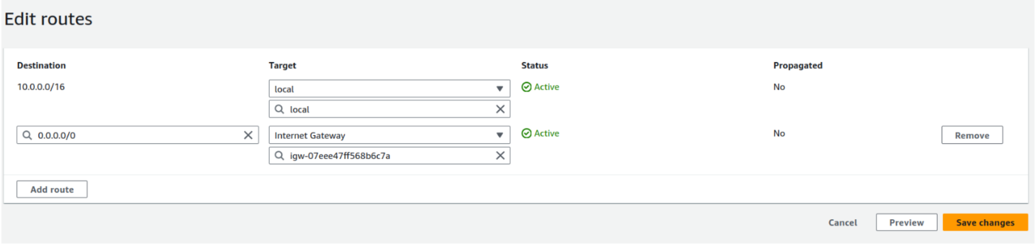

Create an EC2 instance with the VPC and public subnet with key and security group as HTTP and SSH. 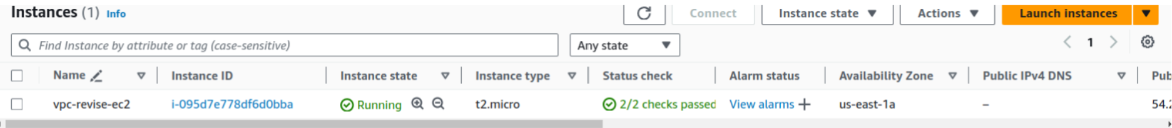

Then we connect to EC2 Instance through our browser.

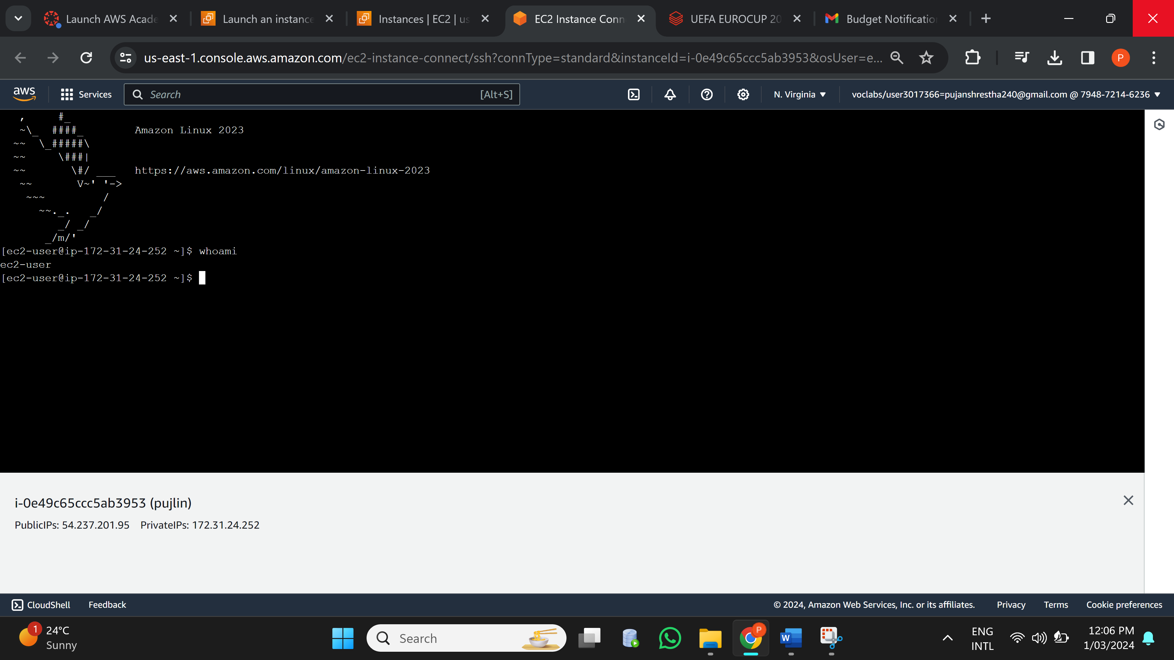

Installing httpd server

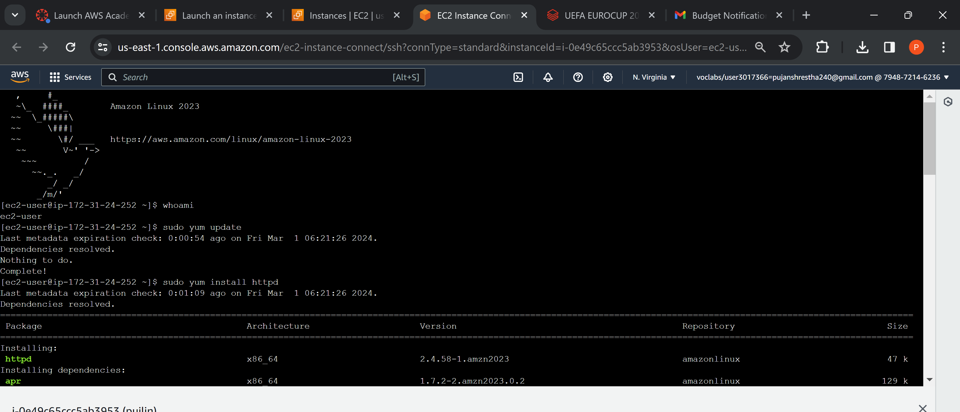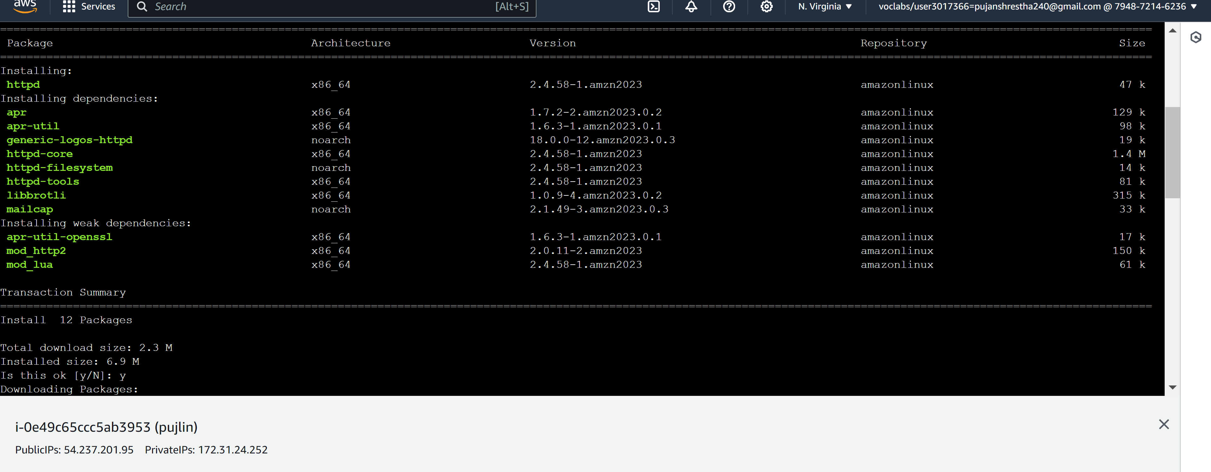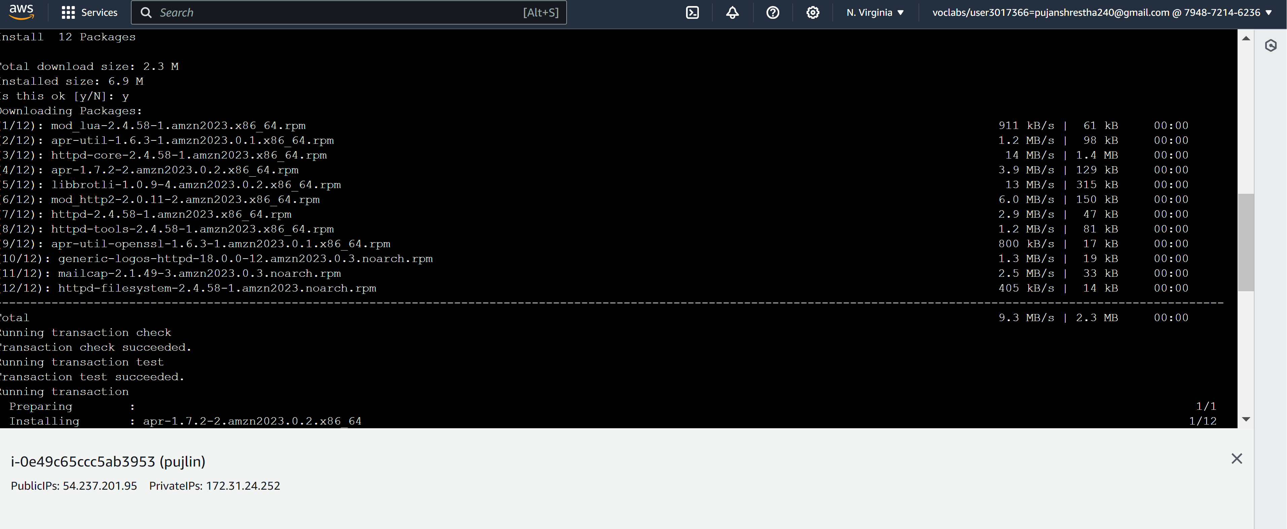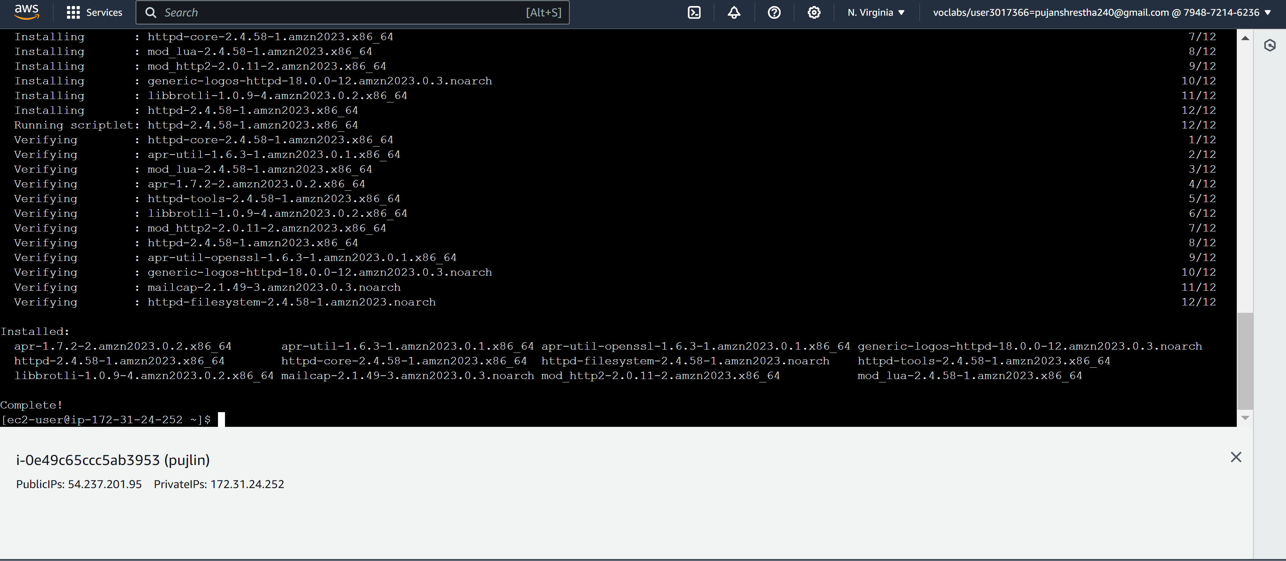

Now, we check the http server. We use our public IP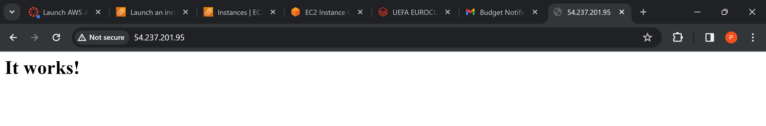

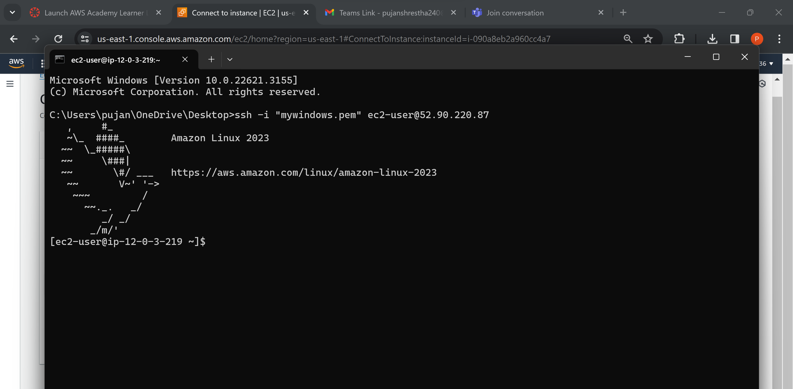

Now we create temp folder to send our website files to our EC2 machine because, it gives problem while sending our static files to /var/www/html/

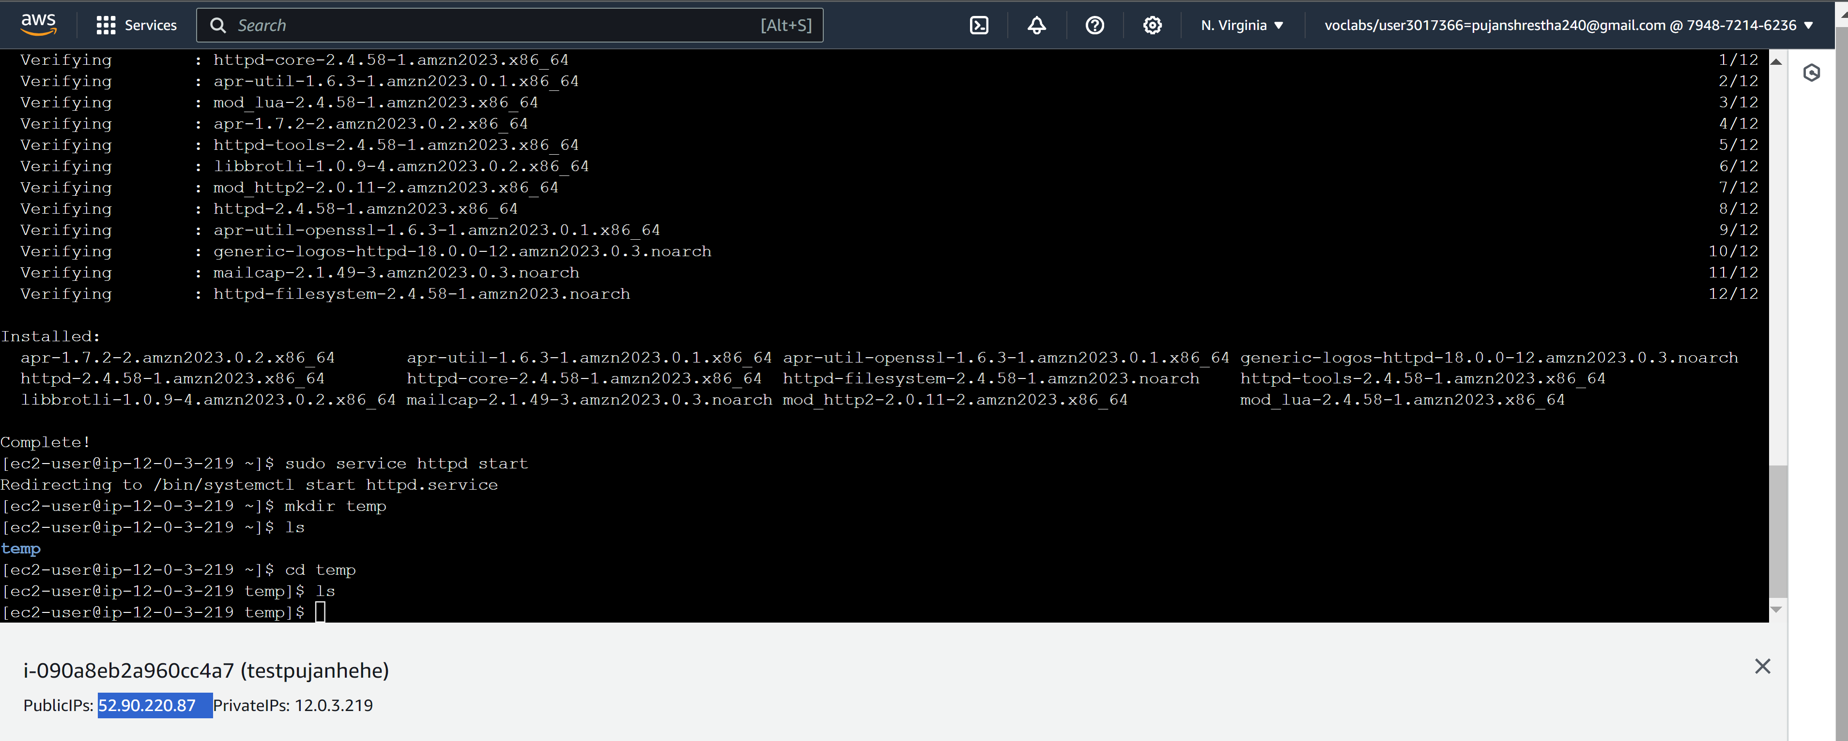

This is how we send our static file to temp folder inside EC2 Machine.

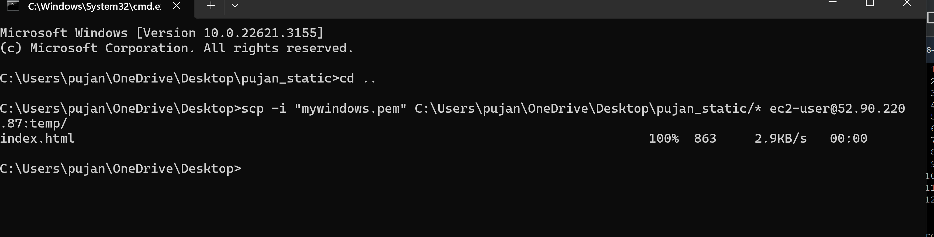

Now, with sudo permission, we transfer the content of temp to /var/www/html/.

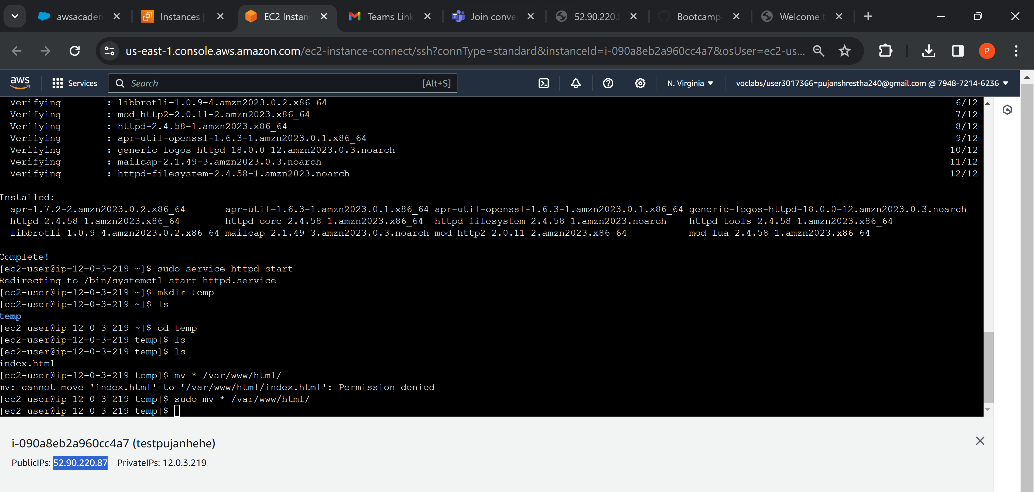

Finally, accessing our hosted website with our public IP Address.

